

Western Australian Certificate of Education
Mock Examination, 2011

Question/Answer Booklet

PSYCHOLOGY

WRITTEN PAPER
Please place your student identification label in this box
Stage 3

Student Number: In figures

In words

Time allowed for this paper
Reading time before commencing work: ten minutes
Working time for paper: three hours

Materials required/recommended for this paper

To be provided by the supervisor
This Question/Answer Booklet
Multiple-Choice Answer Sheet

To be provided by the candidate
Standard items: pens, pencils, eraser, correction fluid, ruler, highlighters
Special items: calculators satisfying the condition set by the Curriculum Council for this course.

Important note to candidates
No other items may be taken into the examination room. It is your responsibility to ensure that you do not have any unauthorised notes or other items of a non-personal nature in the examination room. If you have any unauthorised material with you, hand it to the supervisor before reading any further.
Structure of this paper

Section | Number of questions available | Number of questions to be attempted | Suggested working time  (minutes) | Marks available | Percentage of exam
Section One:  Multiple-Choice | 3 | 3 | 30 minutes | 20 | 20
Section Two:  Short Answer | 5 | 5 | 90 minutes | 50 | 50
Section Three:  Extended Answer | 2 | 2 | 60 minutes | 40 | 30
 |  |  | Total |  | 100

Instructions to candidates

1. The rules for the conduct of Western Australian external examinations are detailed in the Year 12 Information Handbook 2011. Sitting this examination implies that you agree to abide by these rules.

2. Answer all questions by writing your answers in this booklet in the space provided.

3. You must be careful to confine your responses to the specific questions asked and to follow any instructions that are specific to a particular question.

- Spare pages may be found at the end of this booklet. They can be used for planning your responses and/or as additional space if required to continue an answer.
- Planning : If you use the spare pages for planning, indicate this clearly at the top of the page.
- Continuing an answer: If you need to use the space to continue an answer, indicate in the original answer where the answer is continued, i.e. Give the page number. Fill in the number of the question(s) that you are continuing to answer at the top of the page.

Section One: Research Methods 20% 20 Marks

This section has three (3) questions. Answer all questions. Write your answers in the space provided

Suggested working time for this section is 30 minutes.

Question 1

Dr Nichols is a Psychologist interested in how the organisation of concepts in semantic memory might affect the recall of learned information. She predicted that people will recall more words from a studied list if the words are paired with words that are related in meaning.

To investigate this, Dr Nicholls designed a memory experiment in which all participants were presented with the same list of sixty pairs of words to learn.

Half of the word pairs in the study list were related in meaning (e.g. cat–dog, nurse–doctor), and the other half were unrelated in meaning (e.g. paper–shirt, tree–hammer).

After studying the pairs of words the twenty, first year university students, who volunteered as participants, were presented with the first word from each pair as a cue and were required to recall the second word.

Dr Nicholls determined that the results would be significant if the p value obtained was less than 0.05.

The experiment consisted of a study phase and a test phase.
Study phase – All participants were asked to read aloud each of the 60 word pairs in the study list.
• half of the participants studied the 30 related word pairs first, followed by the unrelated word pairs
• half of the participants studied the 30 unrelated word pairs first, followed by the related word pairs
Test phase – The test phase immediately followed the study phase.
Participants were presented with the first word from each of the 60 word pairs as a cue for recall. Their task was to recall the word that had been paired with each cue word.
Results
The results are presented in the graph below. p = 0.02.

Number of words recalled in the cued recall task
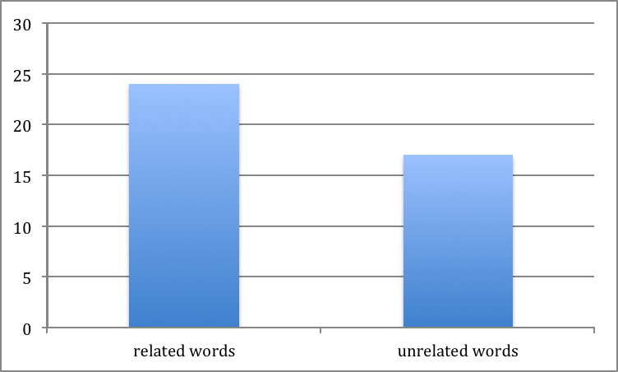

number of
correctly
recalled words
out of 30

(a) (i) What are the independent and dependent variables for this experiment? (1 mark)

Dependent variable _________________________________________________________

Independent variable ________________________________________________________

(ii) Write an operational hypothesis for this experiment (1 mark)

(b) Explain the findings of Dr Nichols experiment with reference to both statistics provided in the graph and the results of the statistical test (p value). (3 marks)

(c) Describe one improvement to this experiment. Provide a reason for your answer. (2 marks)

(d) Name two (2) ethical considerations that must be explained to participants by Dr Nichols before the start of the experiment. Explain why each one is important from an ethical point of view. (2 marks)

Question 2.

A research study was conducted to examine the effects of alcohol consumption and developing feelings of sadness. Fifty participants were randomly assigned to Group A or Group B.

Individuals performed the following sequence of tasks
- Completed a mood rating scale
- Discussed with the researcher three recent times when he/she felt sad:
- Completed the mood rating scale again
- Drank a moderate dose of ‘alcohol’ over a 20 minute period
- Waited 20 minutes for the alcohol to be absorbed
- Completed the mood rating scale again.

All participants were told that they would be given a moderate dose of alcohol to drink but only participants assigned to Group A were actually given alcohol. Group B were given a non-alcoholic beverage that appeared to be alcohol.

- Name the placebo used in this study. Explain the purpose of the placebo in this research design. (2 mark)

(b) (i) Figure 1 below summarises some findings of the study described above. State the
conclusion/s from these findings. (2 marks)

Mood average before an after alcohol drink

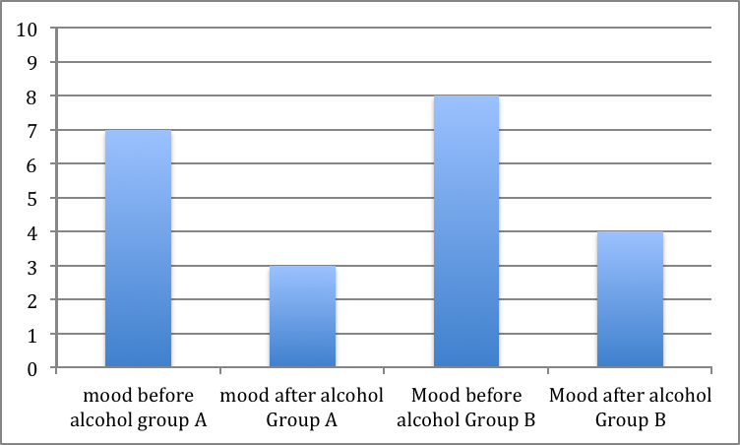

Rating scale
score out of 10
(average for group)

(c) 206 people volunteered for the study but only 50 people were accepted to be participant in the study. Explain, using possible examples related to the study, how this would have made the study design:
- more reliable
- more valid
- more ethical (3 marks)
(i)

________________________________________________________________________________________________________________________________________________________________________________________________________________________________________________________________
(ii)

(iii)

Question 3

- Explain by giving an example of what an objective quantitative measure is in research.
(1 mark)

- Explain by giving an example of what a subjective quantitative measure is in research. (1 mark)

(c) Why would a Psychologist make reference to suggestions for further research directions at the end of the discussion section of his/her investigation? (2 marks)

End of Section One
Section Two: Short Answer 50 Marks

This section has 5 questions. Attempt all questions.

Suggested working time for this section is 90 minutes.

Question 4: Developmental psychology (10 marks)
(a) Name two of the four stages described by Piaget in his theory of cognitive development.
(2 marks)

___________________________________________________________________________

____________________________________________________________________________

(b) Some researchers have criticised the tasks Piaget used with children to develop his theory of cognitive development. Outline two of these criticisms. (4 marks)
Criticism one:

Criticism two:

(c) Despite criticism of Piaget’s research, his theory of cognitive development theory is still influential in psychology today. Explain why this is so? (4 marks)

Question 5: Biological Influences (10 marks)

(a) Outline, using research, how factors such as exercise affect behaviour. (2 marks)

- Explain why researchers use physiological measures when objective quantitative measures are needed in research. Explain and give an example . (3 marks)

(c) (i) What type of measure is a checklist or rating scale (1 mark)

- Explain what is happening in this diagram (4 marks)
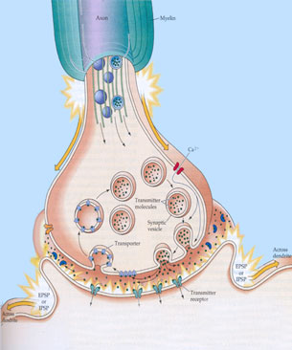
________________________________________________________________________________________________________________________________________________________________________________________________________________________________________________________________________________________________________________________

(NOTE: the words on the diagram are deliberately blurred)
Question 6: Self: Cognition (9 marks)
(a) Explain, using (3) three examples how ADHD can affect behaviour and cognitive skills (3 marks)

(b) Outline 3 different methods of treating ADHD (3 marks)

(c) Explain ‘perceptual expectancy’ in terms of cognition and awareness. Give an example to explain your answer . (3 marks)

Question 7 – Social Psychology (10 marks)

(a) Outline the main ideas of Allports theory in Social Psychology. (4 marks)

ro

(b) Why are Psychologists concerned with inclusivity and difference. (2 marks)

c) Social Psychology is concerned with an individuals behaviour within groups. Outline your understandings of what psychological research has been done on group behaviour. (4 marks)

Question 8 –Social Values and Practices (11 marks)

(a) Explain how families have changed over time. What affect has this had on children within families, use research to support your answer. (4 mark)

(b) How have social values changed and what affect has this had on the role of the community.
(3 marks)

(c ) Outline two examples of how technology has made a positive influence on families. (4 marks )

End of Section Two
Section Three: Extended Answer 30% 40 Marks

This section contains 2 questions. Write your answers on the lined pages provided.

Suggested working time for this section is 60 minutes.

Question 9

Construct an argument with supporting empirical evidence, to explain how personality, intelligence and social values affect a persons position within society.

In constructing your argument you should
- give a clear definition of all terms
- explain how personality affects a persons position within society
- explain how a persons intelligence/cognitive ability affects a persons position within society
- explain how a persons social values affect a persons position within society
- consider how all these influences interact and impact on a persons position within society
- finish with a conclusion

(20 marks)

Question 10

“There is an increase is mental health issues because of political and social unrest”

Evaluate the accuracy of this statement with reference to current psychological understandings related to self, others and society.

In your response:
- begin with a broad evaluation of the statement including definitions of any terms that you consider are necessary,
- include information related to self, others and society,
- show how these psychological understandings interact,
- finish with your conclusion.
Marks will be rewarded for referring to empirical evidence in your answer. (20 marks]

End of questions

